DS 413/613 HOMEWORK / Shiny Apps

**Problem 1** Add two lines of code to the user interface component of the shiny code below to produce the frequency polygon shiny app shown. After adjusting the code in the ui, check to make sure that your app is Reactive.

library(tidyverse) library(shiny)

diamonds%>%

select(carat,price,x,y,z) -> diamonds1

diamonds1

*ui <- fluidPage(*

*titlePanel("Frequency Plots"),*

*)*

*server <- function(input, output) {*

*output$plot <- renderPlot({*

*ggplot(diamonds, mapping = aes(x = .data[[input$DVvar]], color = cut)) +*

*geom_freqpoly(binwidth = 0.1) +*

*ggtitle("frequency polygons")*

*})*

*}*

*shinyApp(ui = ui, server = server)*

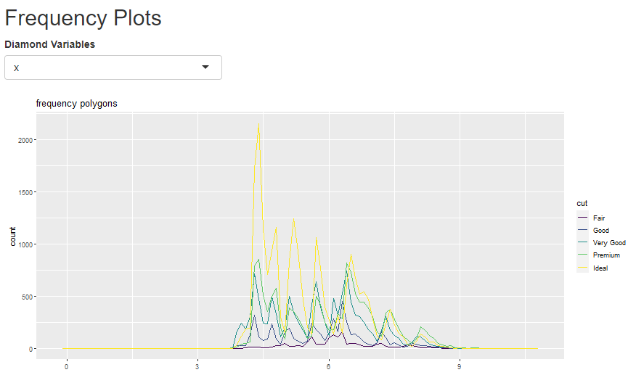

**Problem** 2 Now, continuing adding additional code to the coding chunk for problem 1 to create the Reactive shiny app below. Note that your app produces three Reactive elements; two plots and a dynamic table.

Frequency Plots, Box Plots, and a Table

Diamond Variables



